

**Thermal 1000W Controller Build guide**

This Build Guide is to be used with the following stages:

8” 20C-200C (round)

8” 20C – 150C (round)

12” 20C – 150C

**Cables/Harnesses:**

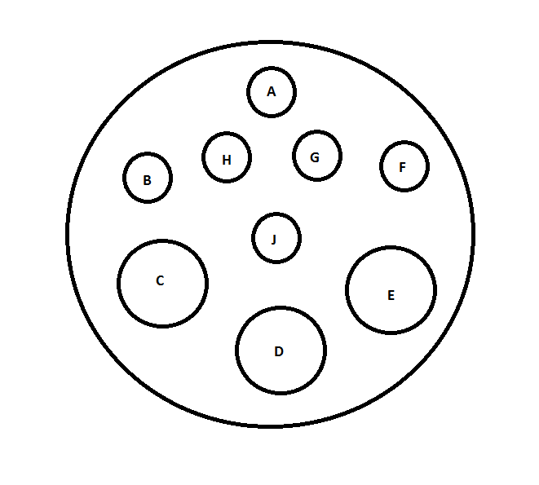

**High Current Stage Connector:**

|  |  |  |  |  |  |
| --- | --- | --- | --- | --- | --- |
| Stage Connector | Gauge | Color | Length | Description | Termination |
| A | **24** | **Green** | **30”** | **RTD+** | **Fork Terminal 6** |
| B | **24** | **Yellow** | **30”** | **RTD-** | **Fork Terminal 6** |
| H | **24** | **Brown** | **30”** | **RTD-** | **Fork Terminal 6** |
| E | **14** | **Black** | **31”** | **TE-** | **Terminal 8** |
| J | **-** | **-** | **-** | **-** | **-** |
| D | **16** | **Green** | **26”** | **Ground** | **MTA .156 J11 pin 3** |
| C | **14** | **Red** | **31”** | **TE+** | **Terminal 8** |
| F | **20** | **Purple** | **23”** | **Bi-Metallic** | **MTA .156 1/2** |
| G | **20** | **Purple** | **23”** | **Bi-Metallic** | **MTA .156 2/2** |

**Athena AC:**

|  |  |  |  |  |  |
| --- | --- | --- | --- | --- | --- |
|  | | Gauge | Color | Length | Termination |
| MTA .156 pin 1/2 | **18** | | **Black** | **16”** | **Fork Terminal 6** |
| MTA .156 pin 2/2 | **18** | | **White** | **16”** | **Fork Terminal 6** |

**Cosel Sense Resistor:**

|  |  |  |  |  |
| --- | --- | --- | --- | --- |
|  | Gauge | Color | Length | Termination |
| .100 1/3 | **24** | **Blue** | **18”** | **Pin 7 of 10 pin Cosel connector** |
| .100 3/3 | **24** | **Green** | **18”** | **Pin 8 of 10 pin Cosel connector** |

**Stage Reset:**

|  |  |  |  |  |
| --- | --- | --- | --- | --- |
|  | Gauge | Color | Length | Termination |
| Reset button 1 | **24** | **Grey** | **25”** | **MTA .156 1/2** |
| Reset button 2 | **24** | **White** | **25”** | **MTA .156 2/2** |

**Cosel AC:**

|  |  |  |  |  |
| --- | --- | --- | --- | --- |
|  | Gauge | Color | Length | Termination |
| MTA .156 1/3 | **16** | **Black** | **21”** | **Terminal 8** |
| MTA .156 2/3 | **16** | **White** | **21”** | **Terminal 8** |
| MTA .156 3/3 | **16** | **Green** | **21”** | **Terminal 8** |

**AC Input:**

|  |  |  |  |  |
| --- | --- | --- | --- | --- |
|  | Gauge | Color | Length | Termination |
| MTA .156 1/3 | **16** | **Black** | **28”** | **Spade Plug** |
| MTA .156 2/3 | **16** | **White** | **28”** | **Spade Plug** |
| MTA .156 3/3 | **16** | **Green** | **28”** | **Spade Plug** |

**9V Connector:**

|  |  |  |  |  |
| --- | --- | --- | --- | --- |
|  | Gauge | Color | Length | Termination |
| MTA .156 1/2 | **20** | **Black** | **15”** | **MTA .156 3/6** |
| MTA .156 2/2 | **20** | **Orange** | **15”** | **MTA .156 1/6** |

**5V to Microprocessor:**

|  |  |  |  |  |
| --- | --- | --- | --- | --- |
|  | Gauge |  | Length | Termination |
| .100 1/2 | **24** | **Red** | **15”** | **.100 1/2** |
| .100 2/2 | **24** | **Black** | **15”** | **.100 2/2** |

**45C Connector:**

|  |  |  |  |  |
| --- | --- | --- | --- | --- |
|  | Gauge | Color | Length | Termination |
| MTA .156 1/2 | **24** | **Blue** | **22”** | **Terminal 8** |
| MTA .156 2/2 | **24** | **Green** | **22”** | **Terminal 8** |

**9V AC:**

|  |  |  |  |  |
| --- | --- | --- | --- | --- |
|  | Gauge | Color | Length | Termination |
| MTA .156 1/3 | **16** | **Black** | **10”** | **MTA .156 3/3** |
| MTA .156 2/3 | **16** | **White** | **10”** | **MTA .156 1/3** |

**AC Switch:**

|  |  |  |  |  |
| --- | --- | --- | --- | --- |
|  | Gauge | Color | Length | Termination |
| MTA .156 1/2 | **16** | **Black** | **10”** | **Spade Plug** |
| MTA .156 2/2 | **16** | **Black** | **10”** | **Spade Plug** |

**Low LED:**

|  |  |  |  |  |
| --- | --- | --- | --- | --- |
|  | Gauge | Color | Length | Termination |
| MTA .156 1/2 | **16** | **Black** | **10”** | **Spade Plug** |
| MTA .156 2/2 | **16** | **White** | **10”** | **Spade Plug** |

**High LED:**

|  |  |  |  |  |
| --- | --- | --- | --- | --- |
|  | Gauge | Color | Length | Termination |
| MTA .156 1/2 | **16** | **Black** | **10”** | **Spade Plug** |
| MTA .156 2/2 | **16** | **White** | **10”/3”** | **Branches out to two Spade Plugs**  **(See Image)** |

**Control Bits:**

|  |  |  |  |  |
| --- | --- | --- | --- | --- |
|  | Gauge | Color | Length | Termination |
| .100 1/4 | **24** | **Green** | **22”** | **.100 1/4** |
| .100 2/4 | **24** | **Blue** | **22”** | **.100 2/4** |
| .100 3/4 | **24** | **White** | **22”** | **.100 3/4** |
| .100 4/4 | **24** | **Black** | **22”** | **.100 4/4** |

**Athena RS232 Communication:**

|  |  |  |  |  |
| --- | --- | --- | --- | --- |
|  | Gauge | Color | Length | Termination |
| Female D9 2 | **24** | **Orange** | **25”** | **Fork Terminal 6** |
| Female D9 3 | **24** | **Red** | **25”** | **Fork Terminal 6** |
| Female D9 5 | **24** | **Black** | **25”** | **Fork Terminal 6** |

**Crydom Cables(1)**

|  |  |  |  |  |
| --- | --- | --- | --- | --- |
|  | Gauge | Color | Length | Termination |
| Terminal 8 | **14** | **Black** | **2.5”** | **Terminal 8** |
| Terminal 8 | **14** | **Black** | **5”** | **Terminal 8** |
| Terminal 8 | **14** | **Black** | **26”** | **Terminal 8** |
| Terminal 8 | **14** | **Red** | **2.5”** | **Terminal 8** |
| Terminal 8 | **14** | **Red** | **5”** | Terminal 8 |
| Terminal 8 | **14** | **Red** | **25”** | Terminal 8 |

**Crydom Cables(2)**

|  |  |  |  |  |
| --- | --- | --- | --- | --- |
|  | Gauge | Color | Length | Termination |
| Fork Terminal 6 | **24** | **Blue** | **11”** | **Fork Terminal 6** |
| Fork Terminal 6 | **24** | **Blue** | **3”** | **Fork Terminal 6** |
| Fork Terminal 6 | **24** | **White** | **11.5”** | **Fork Terminal 6** |
| Fork Terminal 6 | **24** | **White** | **3”** | **Fork Terminal 6** |
| Fork Terminal 6 | **24** | **Red** | **8”** | **Fork Terminal 6** |
| Fork Terminal 6 | **24** | **Red** | **3”** | **Fork Terminal 6** |
| Fork Terminal 6 | **24** | **Black** | **7.5”** | **Fork Terminal 6** |
| Fork Terminal 6 | **24** | **Black** | **3”** | **Fork Terminal 6** |

**Cosel 12V Connector:**

|  |  |  |  |  |
| --- | --- | --- | --- | --- |
|  | Gauge | Color | Length | Termination |
| .100 1/2 | **24** | **Orange** | **20”** | **Pin 3 of 8 pin Cosel connector** |
| .100 2/2 | **24** | **Black** | **20”** | **Pin 5 of 18 pin Cosel connector** |

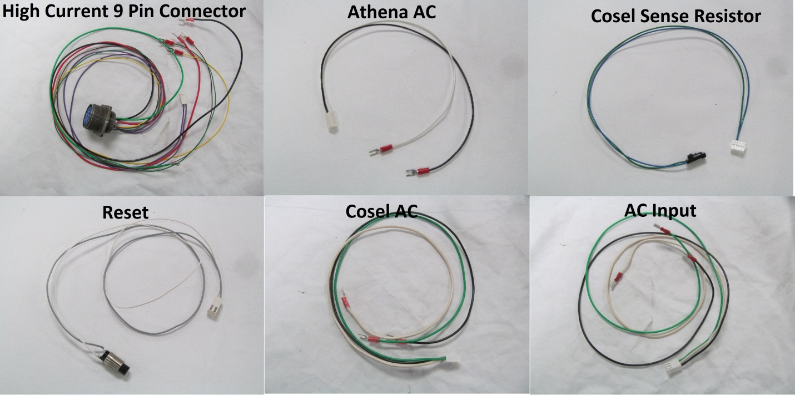

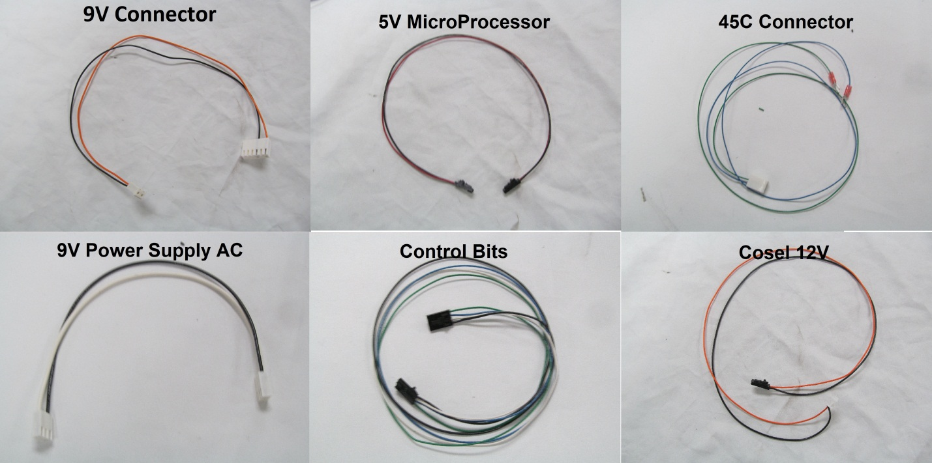

**Relay Board:**

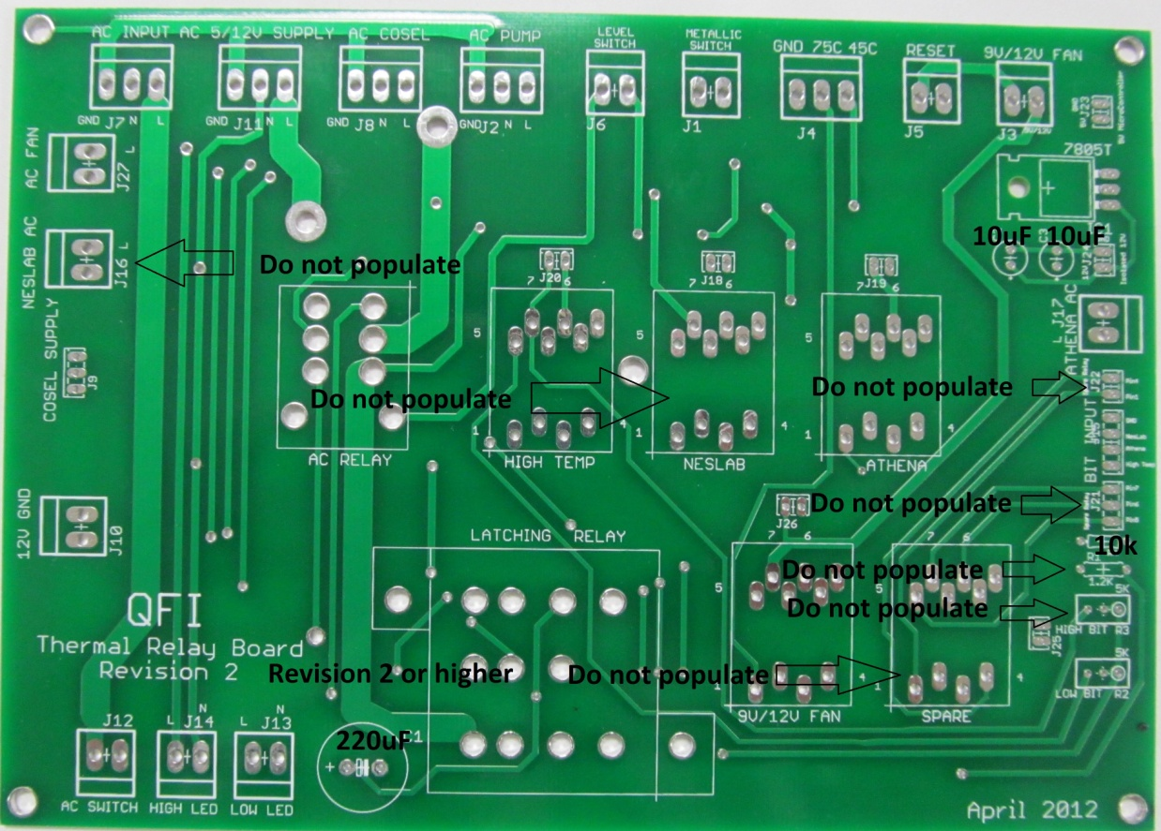

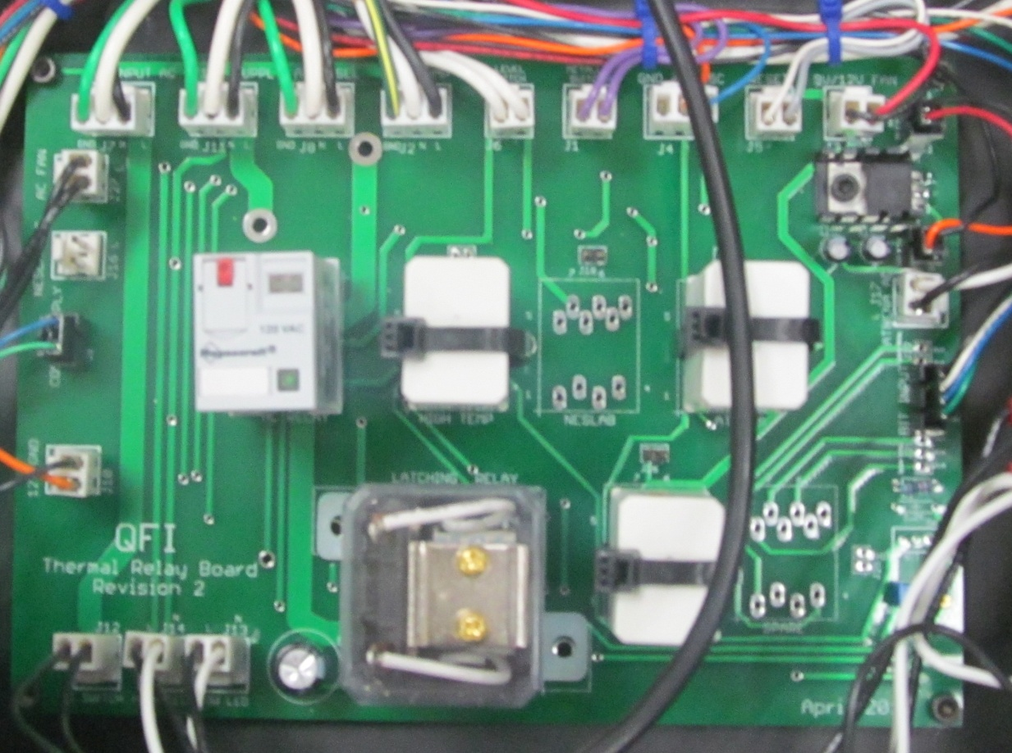

**Crydom H-Bridge:**

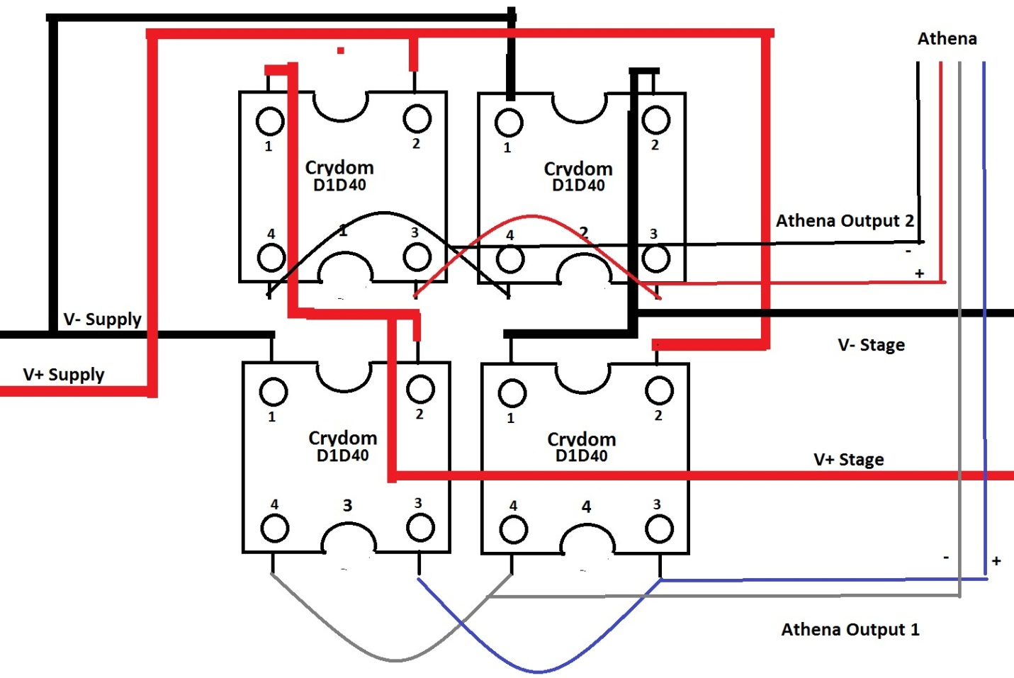

* V+ Supply, V- Supply, V+ Stage and V- Stage use 16 gauge wire
* Athena Output1 and Athena Output 2 use 24 gauge wire
* Crydoms need good thermal contact with Crydom bracket (i.e. Thermal Grease)

**Athena Wiring:**

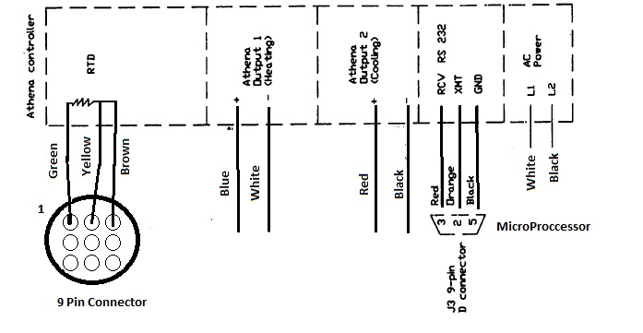

* All wires are 24 gauge; except L1 and L2 are 18 gauge.

**Microcontroller PCB:**

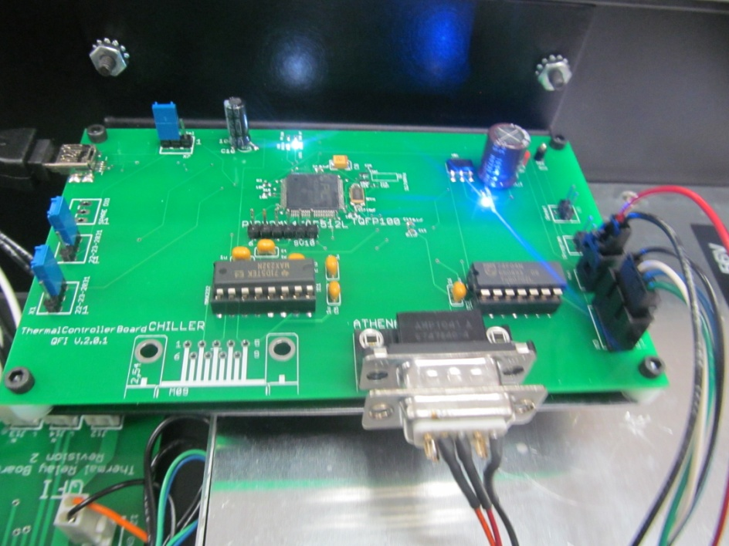

* Program the Bootloader onto the Microprocessor via Pickit3
* Program the UBW32 program onto the Microprocessor via USB.
* **stageThreshold should be set 100.0.** This is located in Athena.h.
* These three steps are explained in Thermal Stage Firmware Tutorial.
* Connect three jumpers as shown in the picture
* Pin 2 of the D9 connector connects to XMT of the Athena. Pin 3 of the D9 connector connects to RCV of the Athena. Pin 5 of the D9 connects to GND of the Athena

**Side Notes:**

* Significant shock vibration is needed between the pump and the bottom of the chassis. Vibrations can cause the hoses/stage to vibrate making measurement acquisition not possible with high resolution lenses.
* The AC fans needs to be tapped for 10-32 screws.
* The radiator fan needs to be tapped for 6-32 screws
* To set high and low voltages first unplug Cosel sense resistor connector. Unplug the Stage. Tweak the pot in the back of the Cosel until the desired voltage is set. Plug in the Cosel sense resistor connector and tweak pot R2 until the desired low voltage is set.
* The high voltage will not “kick in” until the stage reaches 100C. This is to regulate current flow at lower stage temperatures/resistances.

Typical Voltages

|  |  |  |  |
| --- | --- | --- | --- |
|  | High Voltage | Low Voltage | VSwitch |
| 20-150 4” | **52V** | **42V** | **100C** |
| 20-200 4” | **56V** | **42V** | **100C** |
| 20-150 2.5” | **Need Data** | **Need Data** | **Need Data** |
| 20-200 2.5” | **Need Data** | **Need Data** | **Need Data** |

* The microprocessor will shut off the system controller if the Athena does not respond. Once the communication issue is resolved the power switch must be toggled to bring the system back. **The power must be in the off position for at least 10 seconds to insure the firmware will reset correctly.**
* If the Bi-Metallic switch on the stage closes. First turn off the power switch. **Once Again, the power must be in the off position for at least 10 seconds to insure the firmware will reset correctly.** Hold the reset button and turn the power switch on. This will allow water to flow through the stage to remove the heat.
* Add Tube lengths here